Programming Assignment #4
(for Ch 6 and 7)

Problem Description

Use a single-subscripted array to solve the following problem: A company pays its salespeople on a commission basis. The salespeople receive $200 per week plus 9% of their gross sales for that week. For example, a salesperson who grosses $5000 in sales in a week receives $200 plus 9% of $5000 or a total of $650. Write an application (using an array of counters) that determines how many of the salespeople earned salaries in each of the following ranges (assume that each salesperson’s salary is truncated to an integer amount):
- $200-$299
- $300-$399
- $400-$499
- $500-$599
- $600-$699
- $700-$799
- $800-$899
- $900-$999
- $1000 and over
Summarize the results in tabular format.

Note: This problem is question 7.10 on page 295-296. Please see additional requirements at the end of this web page.

Sample Run

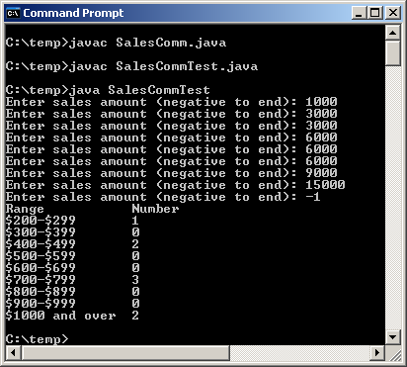

Problem Requirement
a) Your program must produce the prompt and the output the same as given.
- Your program should run correctly with the same inputs and outputs as given in the sample run.
- You should write a method that returns the salary with the gross sales as the function argument.
- You should write a method that takes the salary and the array as the function arguments and increase the appropriate array elements.

